**The Two-Face Protocol**

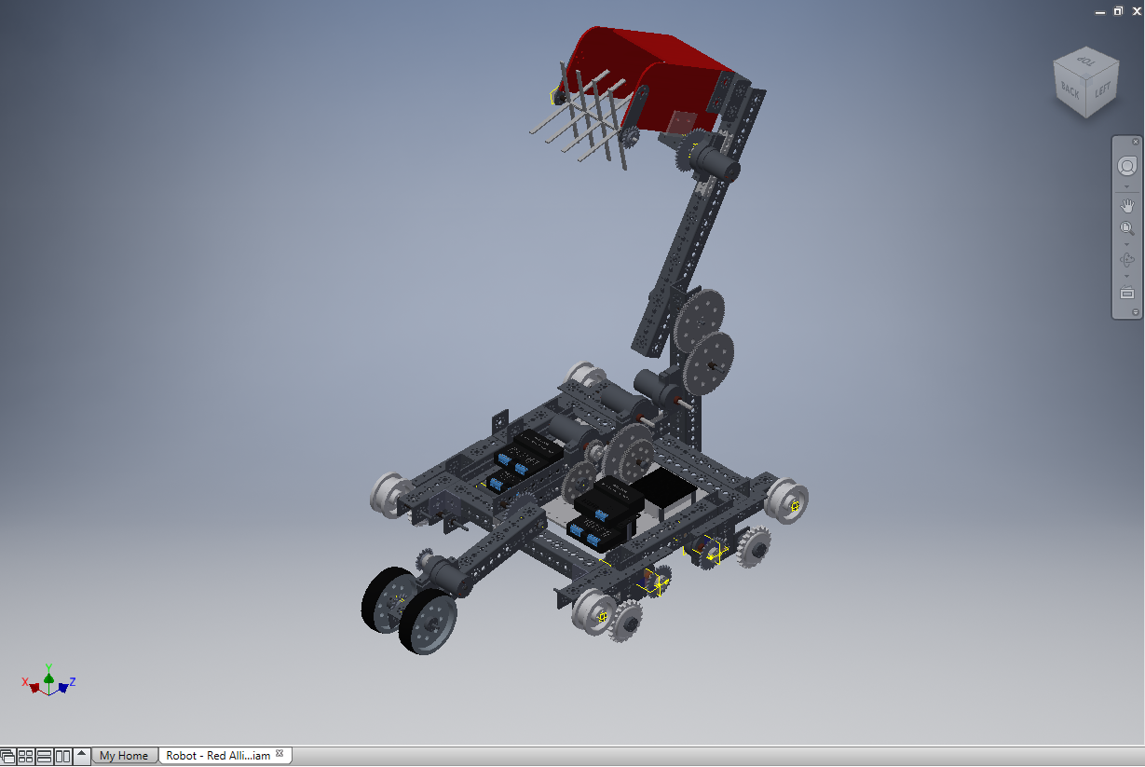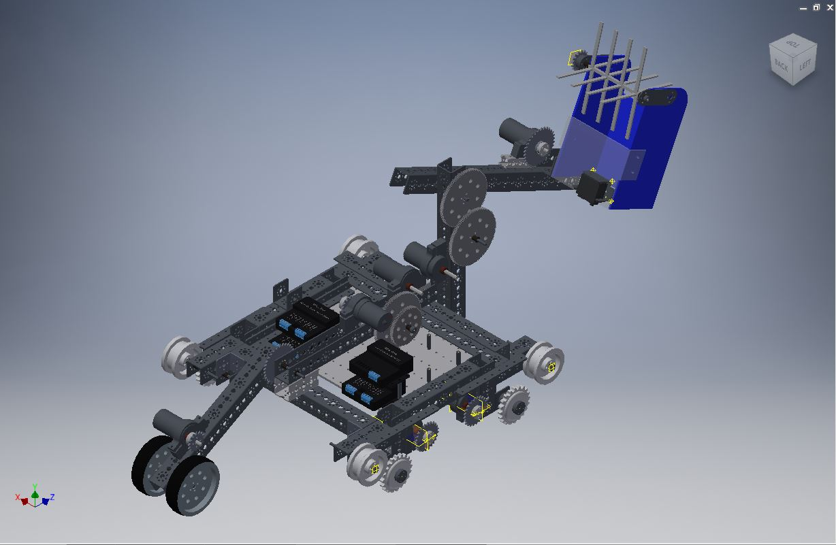

When we started this season out, we designed our robot in a particular way that made it hard to score if we are on the Blue alliance. This is because our chassis and arm placement are set up on the left side of the robot, which gives us the ability to score efficiently on the right side of the ramp. This was a good strategy, unless we are on the blue alliance, for which we can only climb the left side of the ramp. Currently, we still have this design, which we can still use to score in the bottom buckets. Our solution was to design a mirror robot. We took our current design, made a few measurement changes, and then modeled it in reverse. If we have the opportunity to carry out this idea, our robot would have two different arms, and two different wheelie bars.

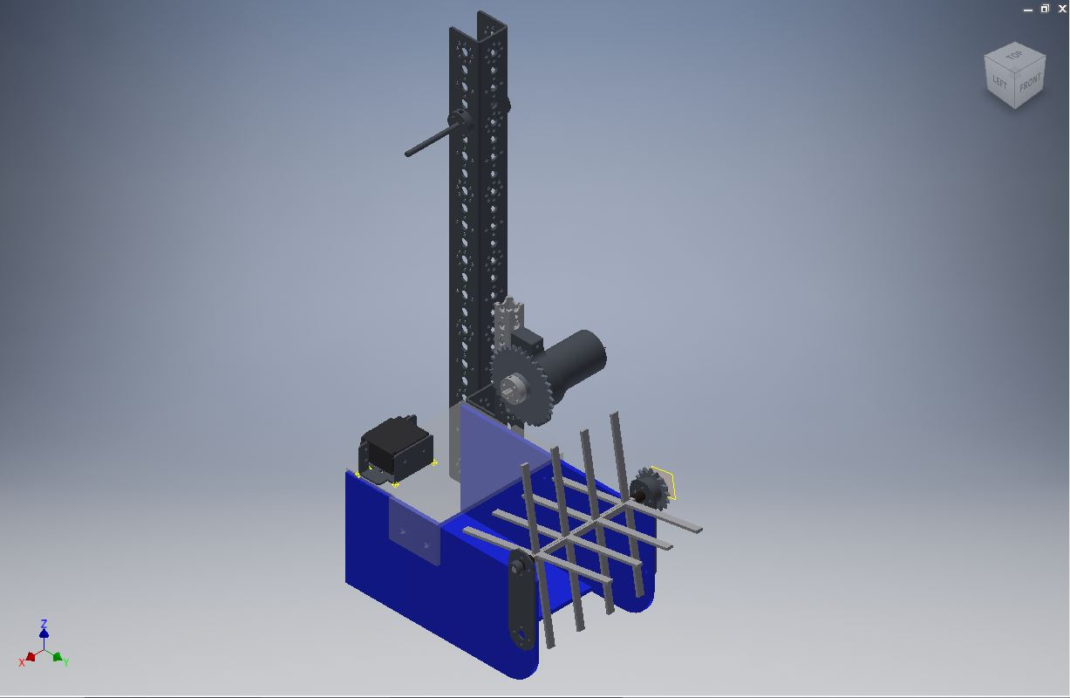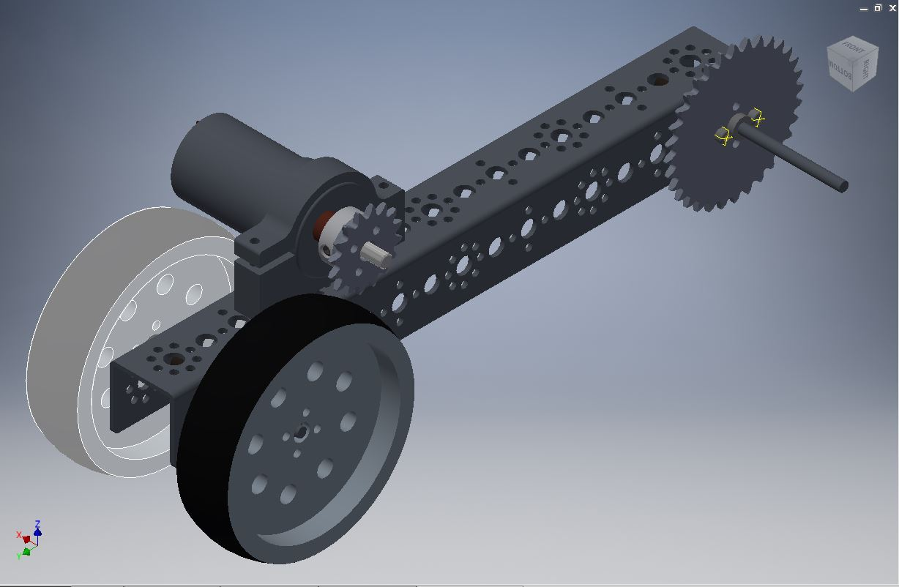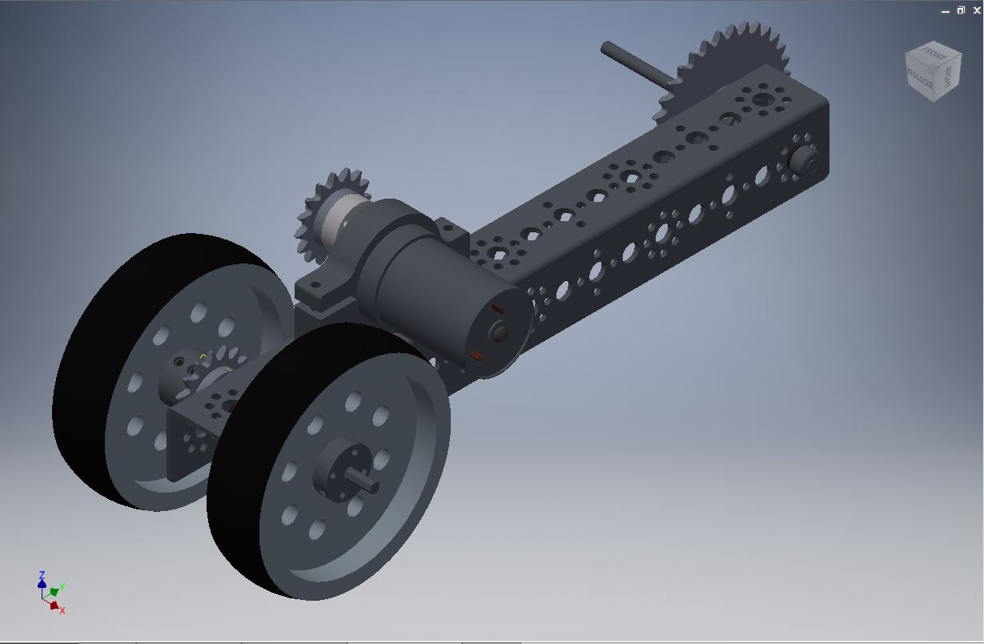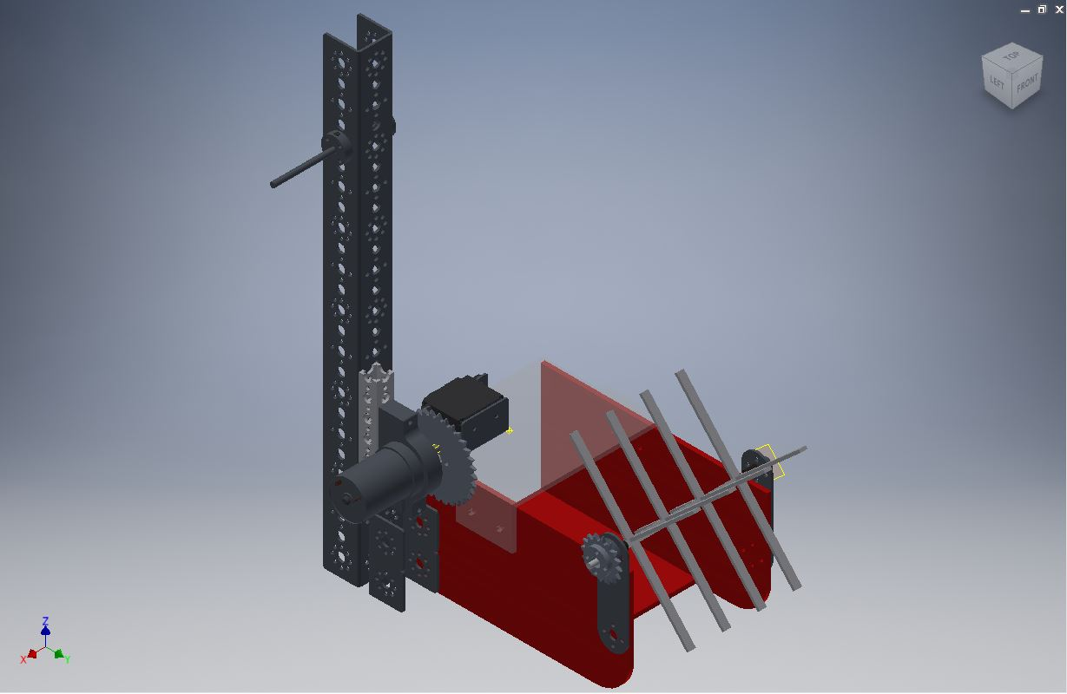

Depending on which alliance we are on for any given mach, we would connect that corresponding arm and wheelie bar assembly. Currently, our robot is set up with parts that resemble the left set of pictures, as we have not been able to complete all the assembly for the right set.